THE UNIVERSITY OF AZAD JAMMU & KASHMIR, MUZAFFARABAD


COURSE TITLE | DSA
COURSE CODE | CS-2101
TITLE | OPEN-ENDED LAB
STUDENT NAME | HASEEB SHEIKH
STUDENT ROLL NUMBER | 2024-SE-31
INSTRUCTOR NAME | ENGR. ASMA JAVED
SUBMISSION DATE | JAN 16, 2025

DEPARTMENT OF SOFTWARE ENGINEERING
DSA
OPEN-ENDED LAB
Objective
The objective of this Open-Ended Lab is to demonstrate self-learning capabilities by implementing Graph data structures in C++. The specific goals are:
- To understand and implement graph representation using an Adjacency Matrix.
- To understand and implement graph representation using an Adjacency List.
- To implement and analyze Breadth-First Search (BFS) using a queue.
- To implement and analyze Depth-First Search (DFS) using recursion
Self-Study
Graph Representations
A graph G = (V, E) consists of a set of vertices V and edges E. I explored two primary ways to represent them in memory:
- Adjacency Matrix: This representation utilizes a 2D array of size V * V where matrix [i][j] = 1 indicates that an edge exists between vertex (i) and vertex (j).
- Advantages: It provides O(1) constant access time to check for the existence of an edge.
- Disadvantages: It consumes O(V^2) space, making it memory-inefficient for sparse graphs.
- Adjacency List: This representation utilizes an array of vectors (or linked lists), where each index (i) stores a list of all neighbors adjacent to vertex (i).
- Advantages: This method is highly space-efficient for sparse graphs, consuming only O(V + E) space.
Graph Traversals
Feature | Breadth-First Search (BFS) | Depth-First Search (DFS)
Traversal Style | Level-by-Level (Wide) | Path-by-Path (Deep)
Data Structure | Queue (First-In-First-Out) | Stack (Last-In-First-Out) or Recursion
Operation | Visits all neighbors before moving down. | Visits one neighbor and goes deep before backtracking.
Key Application | Finding Shortest Path in unweighted graphs. | Solving mazes, Cycle detection, Topology sorting.

Implementation
Task 1: Adjacency Matrix
Problem Statement: Implement a C++ program to represent an undirected graph using a 2D array (Adjacency Matrix). The program should accept user input for vertices and edges.
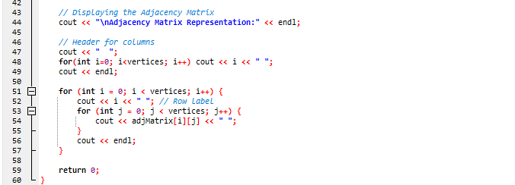
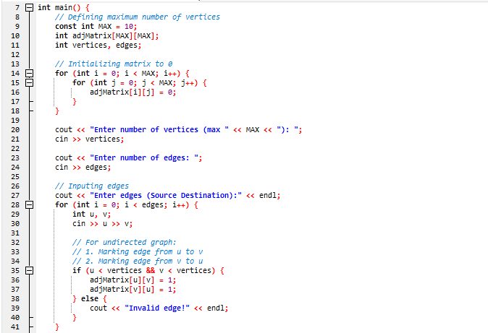
Source Code
Explanation
- Initialization: I declared a static 2D array adjMatrix[10][10] and initialized all cells to 0. This represents a graph with no connections initially.
- Edge Input: The program takes the source (u) and destination (v) for each edge. Since this is an Undirected Graph, I perform two updates for every input: adjMatrix[u][v] = 1 and adjMatrix[v][u] = 1. This ensures the connection is bidirectional.
- Validation: An if condition checks (u < vertices && v < vertices) to prevent array index out-of-bounds errors if the user enters a vertex number larger than the defined size.
- Display: Nested for loops iterate through the rows and columns. If a 1 is found at [i][j], it visually indicates a direct link between vertex i and vertex j.
Output
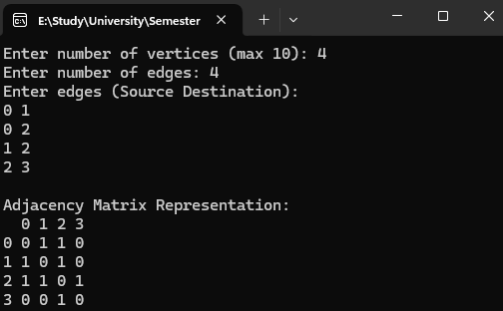

Task 2: Adjacency List, BFS & DFS
Problem Statement: Implement a graph using an Adjacency List. Perform BFS traversal using a Queue and DFS traversal using Recursion.
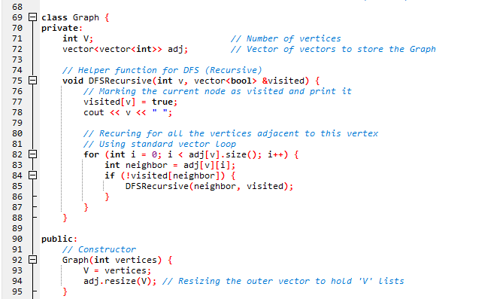
Source Code
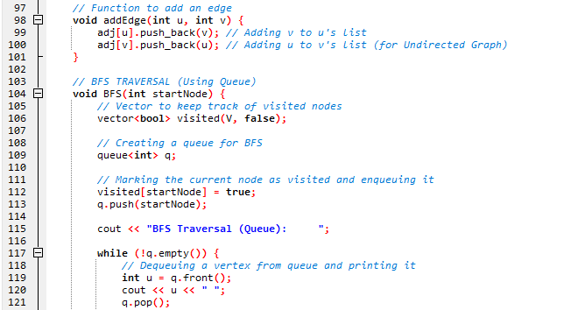
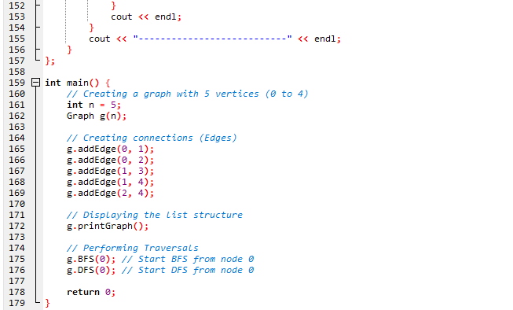
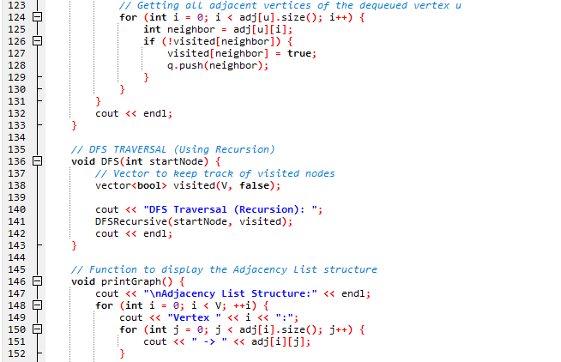
Explanation
Graph Structure (Adjacency List):
- I use vector<vector<int>> adj to create a dynamic list.
- Unlike the matrix, this structure only stores valid connections. The function addEdge(u, v) pushes v into u's vector and vice-versa, utilizing memory efficiently.
BFS Implementation (Queue):
- Mechanism: The starting node is pushed into the queue and marked visited. A while loop runs until the queue is empty. Inside the loop, I pop the front element, print it, and then iterate through its neighbor vector. Any unvisited neighbor is pushed to the queue for future processing.
DFS Implementation (Recursion):
- I utilize the system's call stack via a helper function DFSRecursive.
- Mechanism: The function marks the current node as visited and prints it immediately. It then loops through the neighbors. If a neighbor is unvisited, the function calls itself (DFSRecursive) on that neighbor. This causes the traversal to go as deep as possible into the graph before returning (backtracking).

Main Function


Output

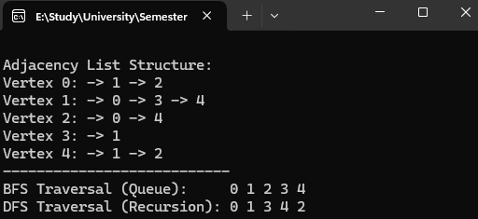

Conclusion
In this Open-Ended Lab, I successfully implemented both core graph representations.
- Adjacency Matrix: I found this easier to implement for dense graphs, but inefficient for large, sparse graphs due to the memory allocation of zeros.
- Adjacency List: Using C++ Vectors provided a dynamic and memory-efficient solution.
- Traversals: I verified that BFS finds the shortest path in unweighted graphs by visiting levels, while DFS explores depth first, which is useful for maze solving and cycle detection.
- Self-Study: I independently researched standard template libraries (<queue>, <vector>) and applied them to solve the problem, moving beyond basic array-based implementations.

